Experiment No. 1 Generation and Classification of Continuous-Time and Discrete-Time Signals
OBJECTIVE:
To generate and visualize basic continuous-time signals such as unit step, unit impulse, ramp, sinusoidal, and exponential signals.
(ii) To generate and visualize basic discrete-time signals and analyze their amplitude and time index characteristics.
(iii) To generate and classify continuous-time and discrete-time signals as periodic or aperiodic based on their periodicity characteristics.
(iv) To decompose a given signal into its even and odd components and verify the reconstruction of the original signal.
Experimental Procedure
1. Define a continuous time vector with a sufficiently small simulation interval.
2. Generate unit impulse, unit step, ramp, exponential and sinusoidal signals.
3. Plot each waveform against time using suitable amplitude and time scales.
4. Measure amplitude, frequency and period wherever applicable.
5. Compare the simulated waveform with its theoretical expression.
6. Record observations and justify the signal characteristics.
PROGRAM CODE:
% Experiment 1: Generation of Continuous-Time Signals
clc; clear; close all;
t = -1:0.001:1;
A = 2; f0 = 5; a = 1;
imp = double(abs(t)<0.0005);
step = double(t>=0);
ramp = t.*step;
expSig = exp(-a*t).*step;
sinSig = A*sin(2*pi*f0*t);
figure;
subplot(3,2,1); plot(t,imp); grid on; title('Unit Impulse'); xlabel('t'); ylabel('Amplitude');
subplot(3,2,2); plot(t,step); grid on; title('Unit Step'); xlabel('t'); ylabel('Amplitude');
subplot(3,2,3); plot(t,ramp); grid on; title('Ramp'); xlabel('t'); ylabel('Amplitude');
subplot(3,2,4); plot(t,expSig); grid on; title('Exponential'); xlabel('t'); ylabel('Amplitude');
subplot(3,2,5); plot(t,sinSig); grid on; title('Sinusoidal'); xlabel('t'); ylabel('Amplitude');
TEST CASE
To generate and visualize basic continuous-time signals such as unit step, unit impulse, ramp, sinusoidal, and exponential signals.
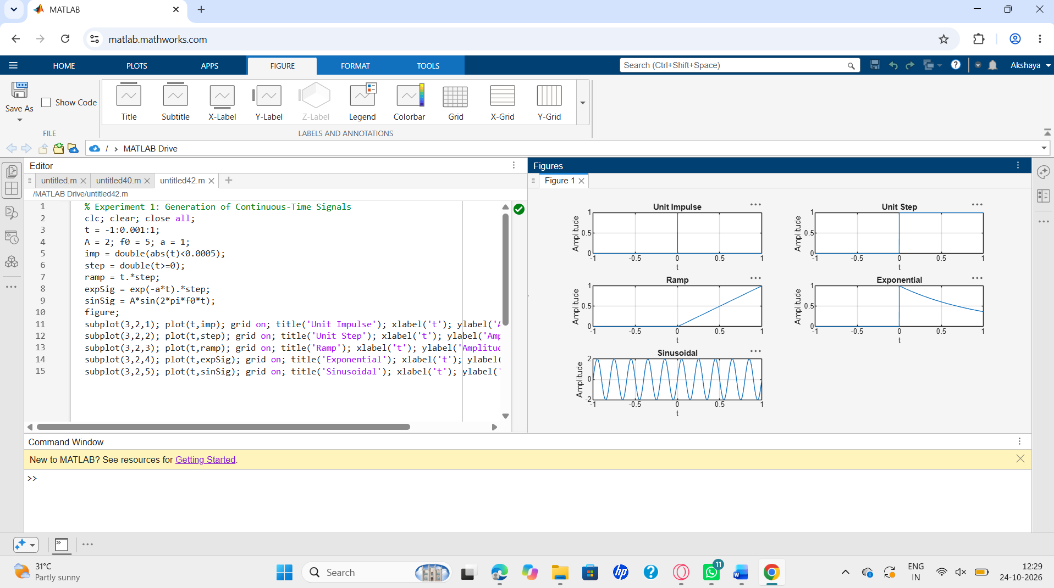
To generate and visualize basic discrete-time signals and analyze their amplitude and time-index characteristics
: Generation of Discrete-Time Signals
clc; clear; close all;
n = -20:20;
A = 2; f0 = 0.1; a = 0.1;
imp = double(n==0);
step = double(n>=0);
ramp = n.*step;
expSig = (0.8).^n .* step;
sinSig = A*sin(2*pi*f0*n);
figure;
subplot(3,2,1); stem(n,imp,'filled'); grid on; title('Unit Impulse');
subplot(3,2,2); stem(n,step,'filled'); grid on; title('Unit Step');
subplot(3,2,3); stem(n,ramp,'filled'); grid on; title('Ramp');
subplot(3,2,4); stem(n,expSig,'filled'); grid on; title('Exponential');
subplot(3,2,5); stem(n,sinSig,'filled'); grid on; title('Discrete Sinusoid');
xlabel('n');
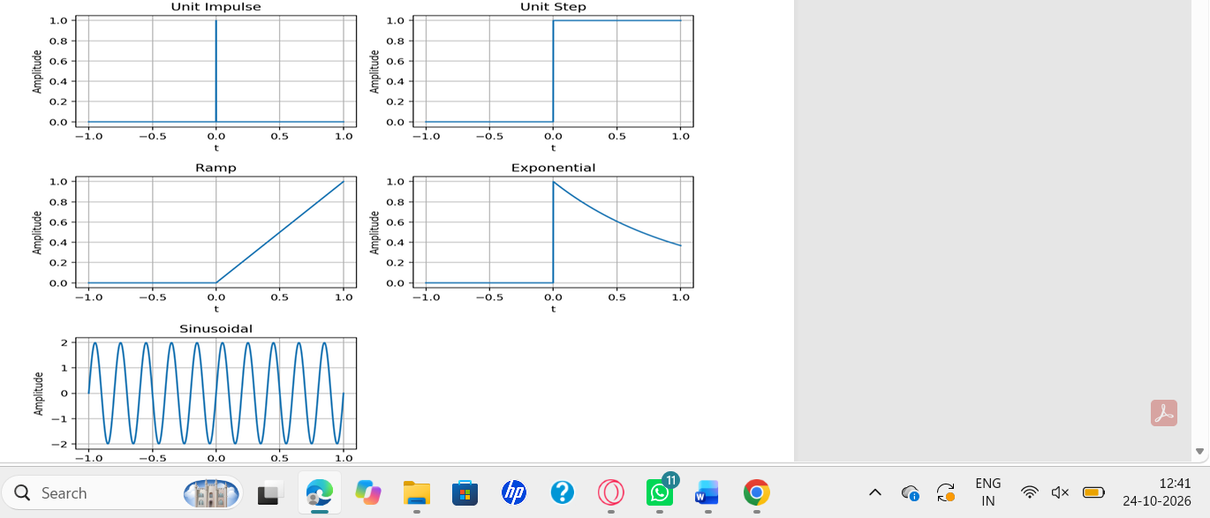
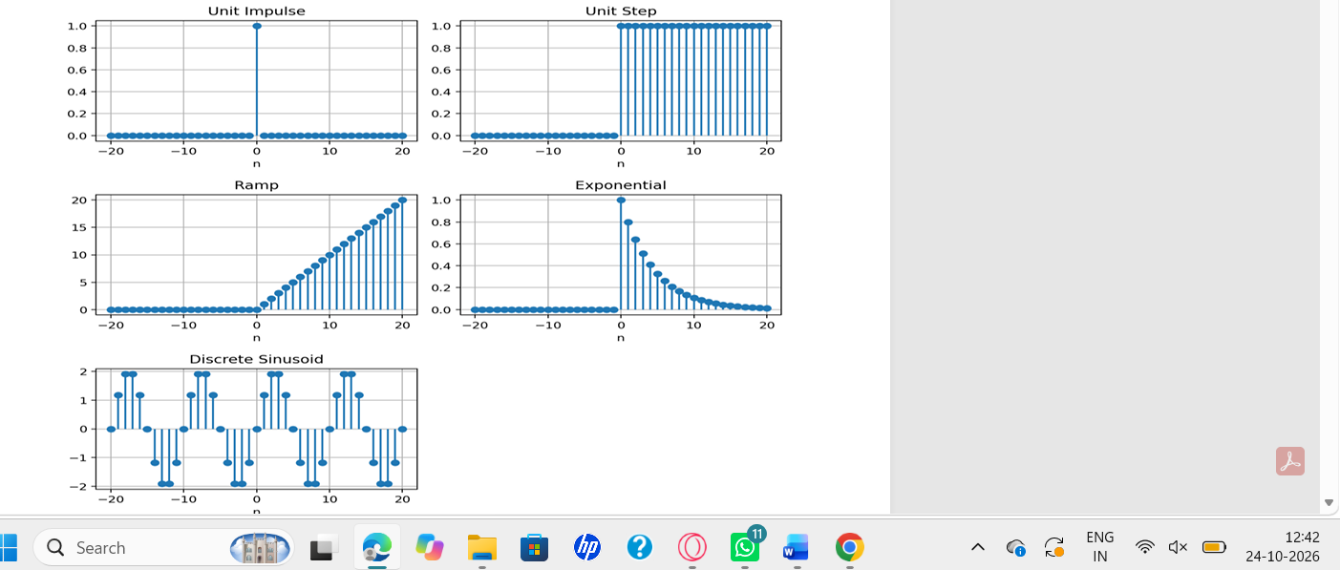

To generate and classify continuous-time and discrete-time signals as periodic or aperiodic based on their periodicity characteristics.
MATLAB Coding % Experiment 5:
Periodic and Aperiodic Signals
clc;
clear;
close all;
t = 0:0.001:2;
f0 = 5;
xP = sin(2*pi*f0*t);
xA = exp(-t)
figure;
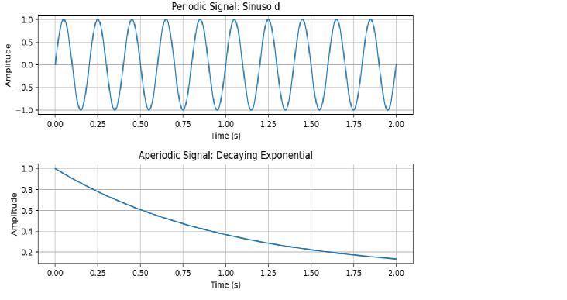(iv) To decompose a given signal into its even and odd components and verify the reconstruction of the original signal.

MATLAB Coding %: Even and Odd Signal Decomposition
clc;
clear;
close all;
t = -1:0.001:1;
x = sin(2*pi*5*t) + 0.5*cos(2*pi*3*t);
xr = fliplr(x);
xe = (x + xr)/2;
xo = (x - xr)/2;
xrec = xe + xo; figure;
subplot(2,2,1);
plot(t,x);
grid on;
title('Input x(t)');
subplot(2,2,2);
plot(t,xe);
grid on;
title('Even Component');
subplot(2,2,3);
plot(t,xo);
grid on;
title('Odd Component');
subplot(2,2,4);
plot(t,xrec);
grid on;
title('Reconstructed x(t)');
fprintf('Maximum reconstruction error = %g\n',max(abs(x-xrec)));

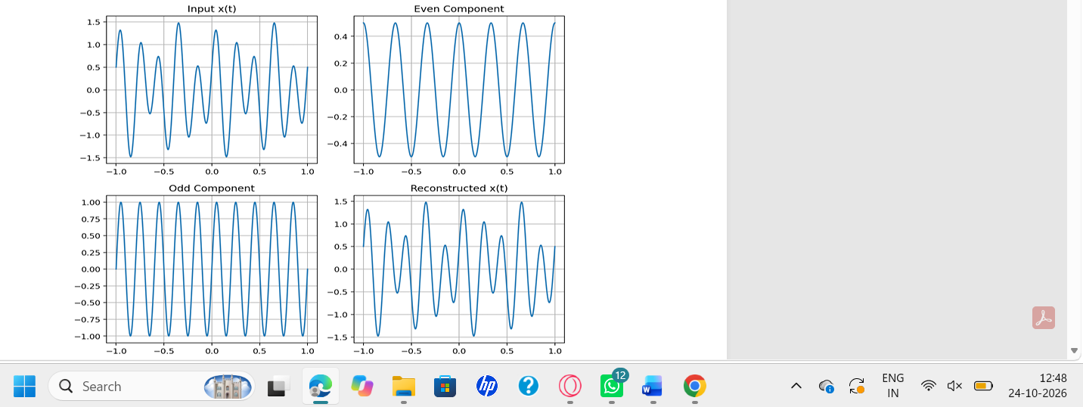
Conclusion

The continuous-time and discrete-time signals were generated and analyzed successfully. The signals were classified as periodic or aperiodic, and the even and odd components were obtained and used to reconstruct the original signal successfully

